FILED

5/9/2023 1:01:31 PM

CADDO BASIN SPECIAL UTILITY DISTRICT
156 CR 1118 • Greenville, TX 75401-7514
Phone (903) 527-3504 • Fax (903) 527-3510
STACEY KEMP
COUNTY CLERK COLL1N COUNTY, TEXAS
BY: KG DEPUTY

DATE:
HOUR:

May 16, 2023
9:00 A.M.
NOTICE OF MEETING

PLACE: District Office located in Floyd, Texas.

AGENDA
- Call to Order.

- Invocation.

- Approval of the Minutes for the April 25, 2023, meeting.

- Consider the Monthly Financial Statement for April 2023.

- Consider acceptance of the 2022-2023 audit.

- Canvass returns & declare results of the May 6,2023 election.

- Operation Manager's Report.

- Executive session in accordance with Articles 6252-17, V.T.C.A Local Government Code to discuss construction contract matters, water supply agreement matters, and/or personnel matters.

- Consideration and possible action regarding matters discussed in executive session.

- Other matters presented by the Board Members, the public, or the staff.

- 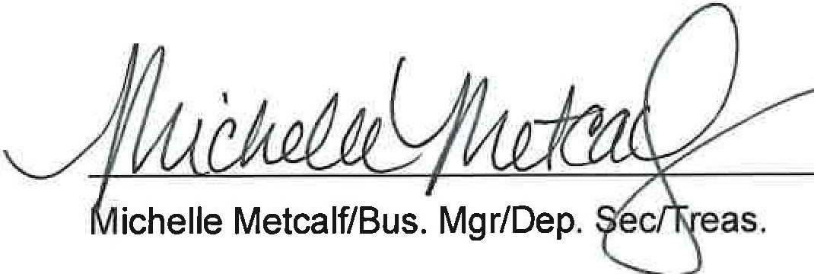Adjourn.,

1

