 | Caddo Basin Special Utility District  156 County Road 1118 Greenville, TX 75401-7514  wwwcaddobasin.com (903) 527-3504

Caddo Basin Special Utility District
Notice of Regular Meeting of Board of Directors
April 22, 2025, at 6:30PM.
Meeting to be held at the District Office — 156 CR 1118, Greenville, TX 75401
AGENDA | FOR RECORD o'clock

APR 1 6 2025
- Call To Order.  - Invocation.  - Public Comment: | 5EcKY LANDRUM  County Oft , Runt County, Ter_  by ^{it}?^{. 5)}

The CBSUD Board will hear public comments for items not listed on the agenda, but any discussion shall be limited to the item being placed on the future agenda for further consideration or, if appropriate_{s} direct the speaker to District staff for more information. Limit individual comments to three minutes with a maximum of fifteen minutes total for public comments.
- Approval of the Minutes:
Discuss and take appropriate action to approve the Minutes of the March 31, 2025, Board Meeting.
- Approval of the Financial Statement:
Discuss and take appropriate action to approve the Monthly Financial Statement for March 2025.

- Approval of the Quarterly Investment Report & Pledge Report:
Discuss and take appropriate action to approve the Quarterly Investment Report & Pledge Report.
- Consider moving Work Orders to a Digital Platform:
Discuss and take appropriate action regarding going to a digital platform for . work orders.
- Operation Managers Report:
Discussion of system repairs, maintenance, and/or customer service matters.
- Executive Session:
;..t.'
At.any time during the meeting and in compliance with the Texas Open Meetings Act, Chapter 551, Texas Government Code, the Board of Directors
1, may meet in executive session on any of the above agenda items or other
iawful items for consultation concerning attorney-client matters (§ 551.071); „deliberation regarding real property (§.551.072); deliberation regarding prospective gift 0551.073); personnel matters (§ 551.074); and deliberation regarding security devices (§ 551.076). Any subject discussed in executive
) action during the open portion of the meeting, The
may be addressed in the order presented or in any


Hunt County-Clerk
Becky Landrum, County Clerk
2507 Lee Street
2nd Floor
Greenville, TX 75401
(903) 408-4130
Receipt: 25-6519
Product Name
PUBNOT PUBLIC NOTICE
No Charge
Public Notice
Total
Tender (On Account)
Account # CADDOBAS
Account CADDO BASIN SPECIAL
Name UTILITY DISTRICT
Balance ($1 e8.00)
Extended
$2.00
false
$2.00
$2.00
$2.00
9cessary by the Board of Directors.
regarding matters discussed in Executive Session.
rd Members, the public, or the staff.
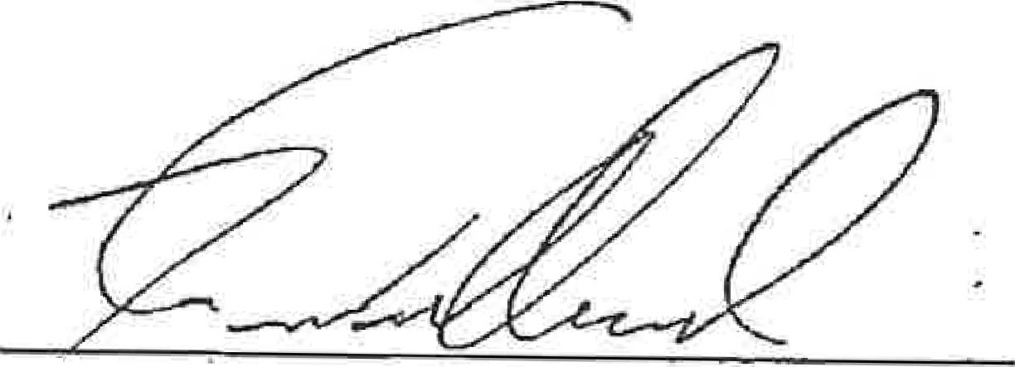
Kevin Wendland, General Manager
Thank You for Your Business 2
4/16125 1:46 PM glorlah

